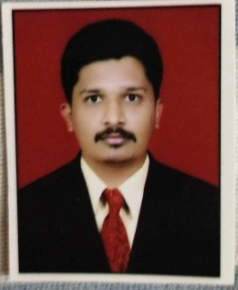
Mr. Ganesh Vijay Bansode

Address:
Behind Bhagwan Vidhyalaya Kingaon
Dist.Latur (M.S) Mobile: 7262856002
Email : ganeshbansode037@gmail.com

Designation: Assistant Professor

Educational Qualification:
SSC : | M.S. Board of HSC & SSC, Latur.
HSC : | M.S. Board of HSC & SSC, Latur
B. Pharm : | Swami Ramanand Teerth Marathwada University Nanded (Jan 2018)
M. Pharm : | Swami Ramanand Teerth Marathwada University Nanded (October 2020)
Specialization : | Pharmaceutical Quality Assurance,
Experiences:
Teaching : | 02 Years

Subjects Taught:
Diploma : | Pharmaceutical Jurisprudence Human Anatomy and Physiology
UG :  PG : | Pharmaceutical Jurisprudence .Physical Pharmaceutics, Biochemistry

Professional Credentials & Recognition:

Professional Membership | : | NA
Research Guidance | : | NA
Books | : | 00
Research papers publication | : | 00
Review articles  Research Projects  Recognitions/ Awards | : | 04
 | :
 | :
 |  | Mr. Bansode G.V.

