Mr. Mujahid Ayyub Sayyed
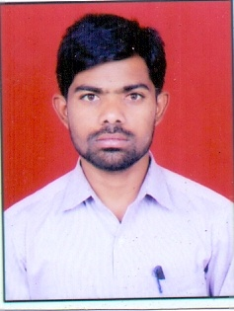
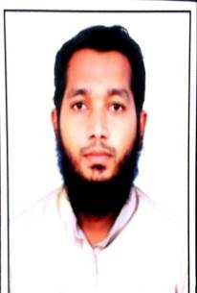

Address:
New Bhagya Nagar, 5 No Chowk,
Dist.Latur (M.S) Mobile: 8975996010
Email : smujahid313@gmail.com

Designation: Sr. Clerk

Educational Qualification:
SSC : | M.S. Board of HSC & SSC, Latur. (First Class)
HSC : | M.S. Board of HSC & SSC, Latur (First Class)
B. A : | Swami Ramanand Tirth Marathawada University, Nanded, M.S. (July-2012) (First Class with Distinction)
M. A : | Swami Ramanand Tirth Marathwada University, Nanded, M.S. (July-2014) (First Class with Distinction)
Specialization:  B.Ed : | Geography  Hindi and Social Science
Experiences:
Non Teaching : | 07 Years

Nature and Duties:
MAHA-DBT All Scholarship Work (D. Pharm, B.Pharm and M. Pharm)
All National Scholarship Work
Maintaining Office Record

Mujahid A. Sayyed

